WALDKIRCH RAIL TOUR 2017
Thursday 22nd June 2017
Departing London St Pancras at 13.00 we change trains in Lille this time and arrive in Strasbourg around 19.00 that evening where a coach will be waiting to transfer you to the Gasthof Rebstock in Oberwinden your base for the next four nights.
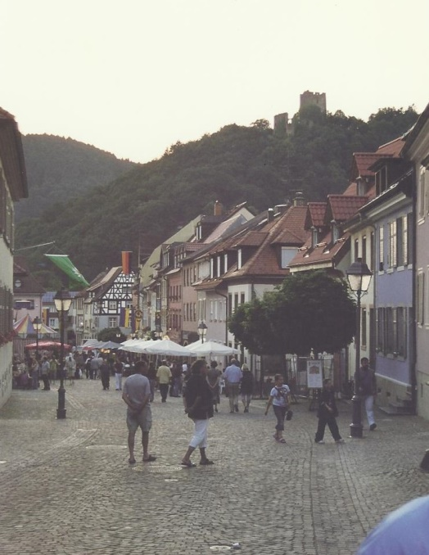
Gasthof Rebstock is a family run German guesthouse where Renate and her family will look after us in their usual style and you will have the local rail ticket to travel freely throughout the area.
Friday 23rd June there will be an optional excursion to Triberg Schwartzwald Museum for those who haven’t been there before with lunch at a local restaurant and a tour in the afternoon of the museum with Black Forest Gateau to finish off. If you simply want some different sightseeing you can walk the highest waterfalls in Germany (entrance close to museum) or simply enjoy the town which is famous for it’s cuckoo clocks and join us for the food before and afterwards.
Saturday 24th you are free to come and go as you please at the show in Waldkirch which speaks for itself.
Sunday 25th a second day at the show or for those who want more touring then a trip along the Hollentalbahn ("Hell Valley Railway") along of the steepest and most stunning railways in Germany to the spa town of Titisee on the shores of the lake. There are other stops along the way if you want to hop on and off!
Monday 26th the coach will pick you up from Oberwinden and take you to Strasbourg for the return trip to London arriving at St Pancras at about 5pm.
Price per person: £550 in a twin room, £600 in a single, with return rail fare, B&B accommodation and coach transfers along with tour escort services. What’s not included, excursions or any other meals than breakfast.
To secure a place with this group please complete a booking form and return it with deposit to the address on the top of the form.

Booking Form
To secure a place on the tour please complete the booking form below and send it to Linda Paskins at Melody Tours, Crinkley Cottage, No 5 High Street, Ilfracombe. North Devon. EX34 9BA. Mob:07786 320394. The landline telephone number is 01271 879621.
Name & Address of Lead Passenger
Telephone : | Mobile:
Email: | Fax:
Name(s) of Passenger(s) as shown on their passport:
1. | 2.
3. | 4.
Please send deposit of £150 per person by cheque to LJ Paskins at the above address. This is required to secure the rail fare as soon as viable. My bank details will be supplied on request for a transfer if preferred.
I agree that in the event of cancellation within one month of departure I will honour the payment if Melody Tours is unable to negotiate a refund with suppliers.

Signed:………………………………………………………………………………Date….…………………

